Lizzy and Jonathan Lesson Plan 2 Title:___Transportation Sculpture____ Length:___Three 90 minute class periods____

Note: Before you plan and write art experiences; pre-assess your students based on the proposed concepts, enduring understandings, and objectives of the unit/lesson(s). You may also gather this information from (previous) teachers, by reviewing already completed art work, consulting curriculum materials, etc., to get a better understanding of what content students already know and what they will need to know to be successful.

Pre-Assessment:
This will need to be done prior to teaching your lesson. Outline the method you will use to determine the skill/knowledge level of your students based on the concepts/enduring understandings/objectives of the lesson. (Hint: turn these into questions.) Be specific in describing what you would recognize as proficient skill/knowledge.
-How well can the student brainstorm and discuss functionality components of a vehicle based on what type of environment it goes in?

-Do the students know what form is in art and how to use it?

-Shown artwork by contemporary artists and by fellow students, how well can the student make and explain inferences about the influences and intent of the artwork with an emphasis on found materials?

- Shown examples of sculptures with varying degrees of quality craftsmanship, can the students identify each artwork’s level of quality and explain why?

-Based on the previous project, how clearly were the students able to discuss and reflect upon their artwork’s strengths and weaknesses?
Inquiry questions:
Circle:
-“What’s your favorite mode of transportation?”
-“What is form in art?”
-“How do artists decide what to title their artworks?”
Discovery board:
-How is your transportation going to be/show both Technology and Art?
-What was your favorite material to work with today and why? Least favorite?
-How will viewers know how your transportation works and what sort of world it belongs to?
In-progress critique:
-What do you like about this piece so far? Why? How does your transportation piece function or work on the habitable planet you created?
-Which photo or video shown during class inspired your mode of transportation the most? (describe as best as you can!)
-What are your plans to finish the piece?
-If your transportation could be used today, how could it best be used on Earth?

Performance:
What will students accomplish as a result of this lesson? This can be presented to students in the form of a story. In this narrative the students take on a role and create a learning product about a specific topic for a certain audience. (RAFT – Role / Audience / Format / Topic)
Your new planet has passed Earth’s tests for a sustainable life- that means it is time for people to start moving to your planet from Earth! Before the spaceship of people arrive, you need to create a way for them to get around your planet. Just like we have cars, buses, trains and planes here on Earth, your planet needs to give people the ability to get around! Your MISSION is to create a new vehicle for your planet!

- the students will have created a 3 dimensional transportation object

Concepts:
List the big ideas students will be introduced to in the lesson. These ideas are universal, timeless and transferable. Examples of concepts used in art might include: Composition, Patterns, Technique, Rhythm, Paradox, Influence, Style, Force, Culture, Space/Time/Energy, Line, Law/Rules, Value, Expressions, Emotions, Tradition, Symbol, Movement, Shape, Improvisation, and Observation Look for concepts in the standards, content specific curriculum, etc.
Space/Time/Energy
Form
Style
Observation
Force
Craftsmanship
Functionality

Enduring Understanding (s):
Enduring Understandings show a relationship between two or more concepts; connected with an active verb. The best enduring understandings not only link two or more concepts; but demonstrate why this relationship is important. Like concepts, they are timeless, transferable and universal. Align Standards, Prepared Graduate Competencies (PGCs) and Grade Level Expectations (GLEs) to Enduring Understandings.
Through art-making, artists and designers make meaning by investigation and developing awareness of perceptions, knowledge, and experiences
(Comprehend / Recognize, interpret, and validate that the creative process builds on the development of ideas through a process of inquiry, discovery, and research / Visual arts learning involves analyzing the formal and sensory qualities of art)

Artists and designers experiment with forms, structures, materials, concepts, media, and art-making approaches
(Create / Create works of art that articulate more sophisticated ideas, feelings, emotions, and points of view about art and design through an expanded use of media and technologies / Use artistic media and expression to communicate personal and objective points of view)

Standards: (All lessons should address all standards.)
1. Observe and Learn to Comprehend
2. Envision and Critique to Reflect
3. Invent and Discover to Create
4. Relate and Connect to Transfer

Objectives/Outcomes/Learning Targets:
Objectives describe a learning experience with a condition → behavior (measurable) → criterion. Aligned to: Bloom’s – Standards – GLEs - Art learning and, when appropriate, Numeracy, Literacy and Technology. Should be written as: Objective. (Bloom’s: _____ - Standard: _____ - GLE: _____ -Art learning: _____ -Numeracy, Literacy, and/or Technology)
5 Categories of Objectives:
o Ideation
o Inherent characteristics / expressive features (elements and principles)
o Media / techniques
o Art history / culture
o Reflection / assessment

-Given the RAFT prompt from this lesson, TSWBAT brainstorm innovative transportation designs that are original and well thought out, and correlate to the world they designed in the previous lesson. (Creating - Reflect - GLE 2 - Ideation - Literacy/Numeracy)

-Given various sculptural materials, TSWBAT create a full round sculpture that demonstrates the inherent characteristics and expressive features of art, with an emphasis on form. (Creating- Create- GLE 1 - Inherent characteristics / expressive features)

-Shown assembled artwork by contemporary artists (in our power-point: see attached) and by fellow students, TSWBAT make and explain inferences about the influences and intent of the artwork. (Analysing - Comprehend - GLE 2 - Art history / culture - Literacy)

- Given various sculptural materials, TSWBAT create a full round sculpture of an original mode of transportation with careful craftsmanship and implied functionality that is relevant to their designed world. (Applying - Comprehend - GLE 3 - Media / techniques)

-Using their completed sculptures, TSWBAT reflect upon and discuss the use of form, functionality, and correlation to their designed world. (Evaluating- Transfer- GLE 1 - Reflection / assessment - Literacy)

Differentiation:
Explain specifically how you have addressed the needs of exceptional students at both end of the skill and cognitive scale. Describe the strategies you will use for students who are already proficient and need growth beyond what you have planned for the rest of the class, as well as modifications for students with physical and/or cognitive challenges. Students must still meet the objectives.

Differentiation:  (Multiple means for students to access content and multiple modes for student to express understanding.) | Access (Resources and/or Process) | Expression (Products and/or Performance)
 | -Allow students to express their brainstorming ideas in writing  or in words  -Provide modeling clay for students to brainstorm their ideas kinesthetically | -Written / verbal brainstorming  -Allow for smaller vehicles, less materials used
Extensions for depth and complexity: | Access (Resources and/or Process) | Expression (Products and/or Performance)
 | Have students draw or plan how their vehicle would fit into the world they designed for the last lesson | Students can make an environment around their vehicle, add detail / color, or make it functional

Literacy:
List terms (vocabulary) specific to the topic that students will be introduced to in the lesson and describe how literacy is integrated into the lesson.
Three Dimensional
Transportation (and how it compares to Earth’s transportation)
Form (3D) vs. Shape (2D)
Functionality (Does it actually work?)
Knowing and understanding the vocabulary above, written and verbal activities will be accomplished during class to show the students understanding of each concept and their expected outcome.

Materials:
Must be grade level appropriate. List everything you will need for this lesson, including art supplies and tools. (These are the materials students will use.) List all materials in a bulleted format.
-Recyclable materials (cardboard, plastic)
-Hot glue guns
-Pipe cleaners
-Modeling clay
-Sketchbooks
-Bags of drawing materials
-Markers
-Scissors

Resources:

List all visual aids and reference material (books, slides, posters, etc. Be specific; include title, artist, etc. Make reference to where the material can be found. (These are the resources used by the teacher to support/develop the lesson.) List all resources in a bulleted format.
-Sculpture examples of varying quality
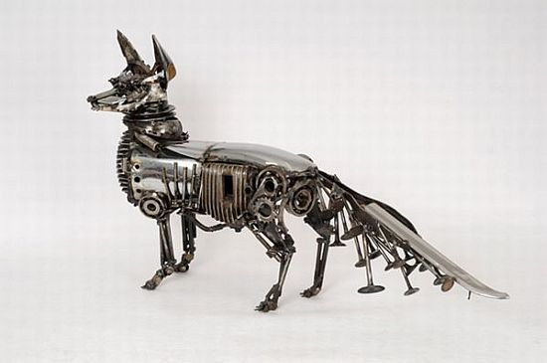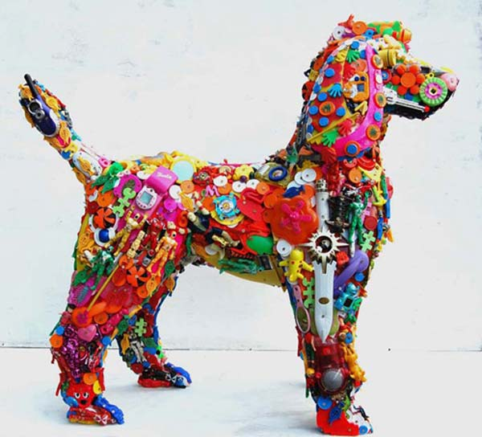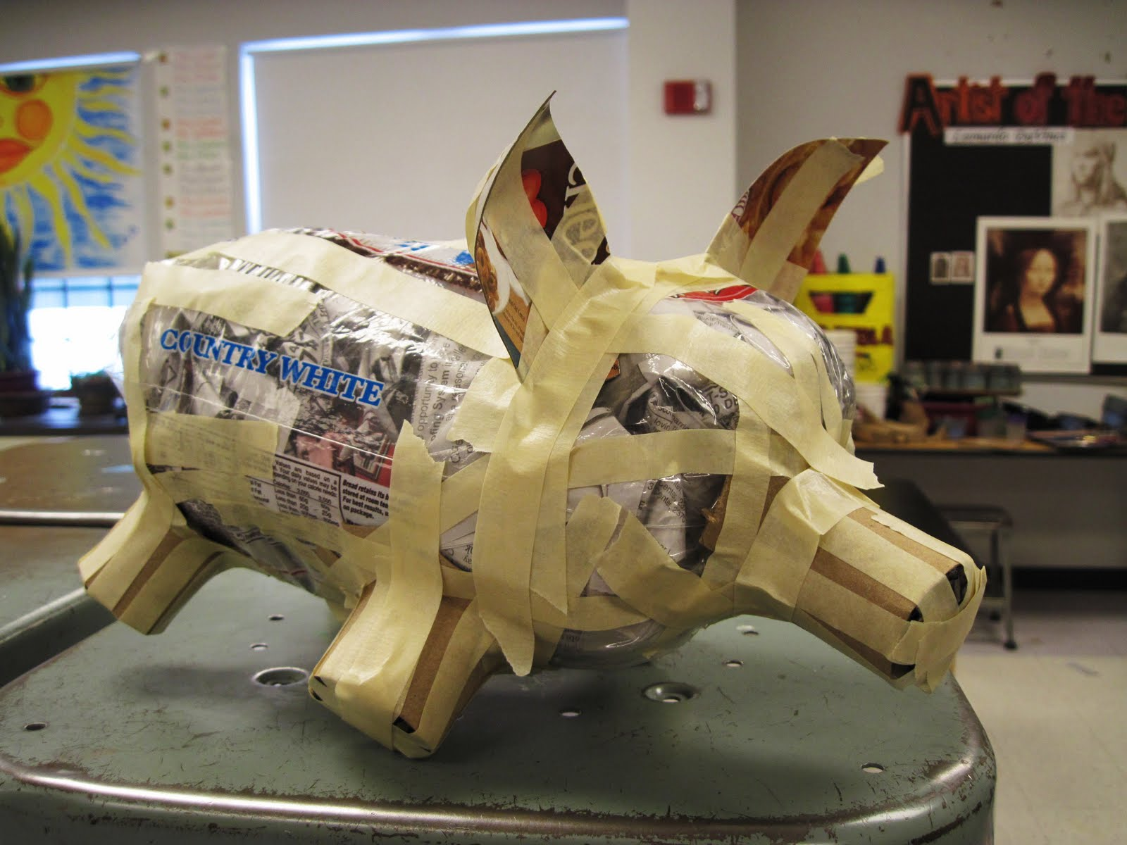

-Examples of old forms of transportation and the evolution to modern innovative transportation
-Hover drone: https://www.youtube.com/watch?v=Bfa9HrieUyQ
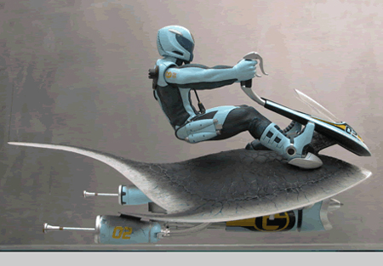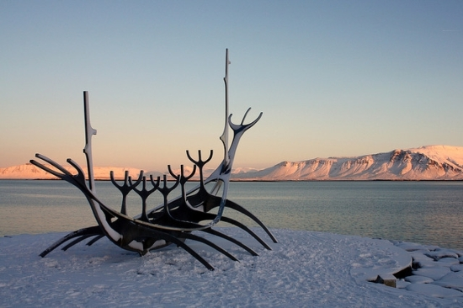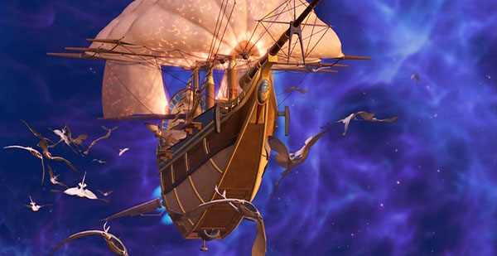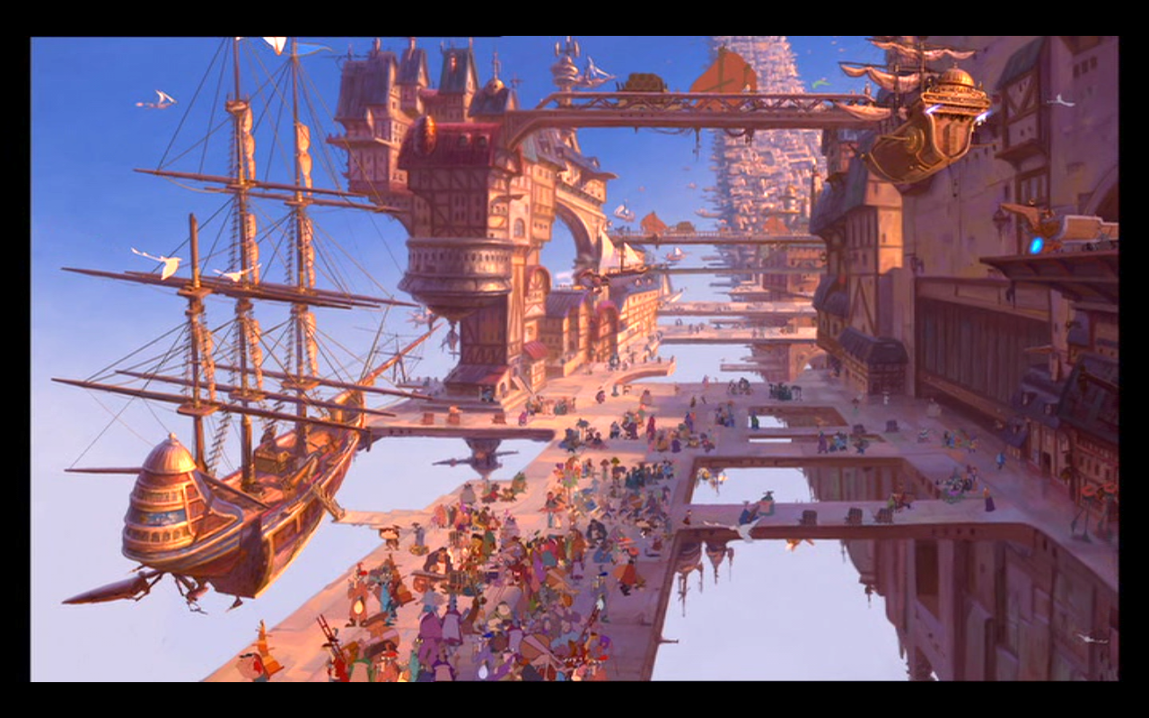
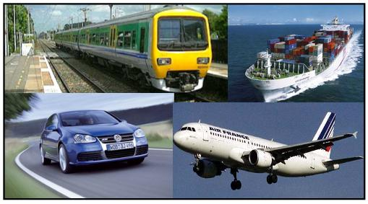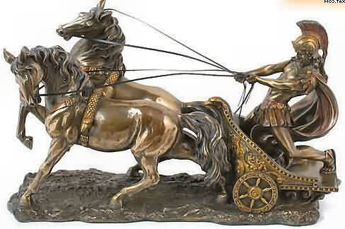
-Short clip from Top Gear before critique to demonstrate a humorous and engaging approach to discussing vehicle characteristics (ADD)
https://www.youtube.com/watch?v=uiXu7LwXRO8 Stop playing at 2:20 min. Talk about the necessities of your world- do you have lots of water and need transportation like this? Will your transportation go under or over the water/land?
https://www.youtube.com/watch?v=mkpCzp0CmjY Play starting at 1:52 min and stop at 4:50- talk about things like “roadways” or “tracks” and will your travel be more about speed or sight seeing?

Preparation:
What do you need to prepare for this experience? List steps of preparation in a bulleted format.
-Find sculpture examples of varying quality
-Find video / photos of innovative futuristic transportation
-Make PowerPoint of the above resources
-Obtain and transport modeling clay, as well as any other materials we don’t already have in the bucket
-Bring sketchbooks
-Save up and bring recyclable materials
-Plan where to store student work

Safety:

Be specific about the safety procedures that need to be addressed with students. List all safety issue in a bulleted format.
-Classroom rules apply during Art time- the students will be held to the same expectations.
(ex: no running, no throwing materials, respect your neighbors’ space...etc)
-Rules of using hot glue guns: never touch the tip, never point at or horseplay with your neighbor

Action to motivate/Inquiry Questions:
Describe how you will begin the lesson to stimulate student’s interest. How will you pique their curiosity and make them interested and excited about the lesson? What inquiry questions will you pose? Be specific about what you will say and do to motivate students and get them thinking and ready to participate. Be aware of the varying range of learning styles/intelligences of your students. Some ideas might include: telling a story, posing a series of questions, role-playing, etc.
Resources: We will be showing awesome artist examples of sculpture, and videos of exciting, groundbreaking modes of futuristic transportation to get the students excited and give them some ideas of what’s possible! (see resources section for specific examples)

RAFT: Your new planet has passed Earth’s tests for a sustainable life- that means it is time for people to start moving to your planet from Earth! Before the spaceship of people arrive, you need to create a way for them to get around your planet. Just like we have cars, buses, trains and planes here on Earth, your planet needs to give people the ability to get around! Your MISSION is to create a new vehicle for your planet!

Ideation/Inquiry:
Ideation is the creative process of generating, developing, and communicating new ideas, where an idea is understood as a basic element of thought that can be visual, concrete or abstract. List and describe inquiry questions and processes you will engage students in to help them develop ideas and plans for their artwork.
-How will the people on your planet get around? Where will they need to get around to?
-What is the relationship between technology and art? How is your transportation art? -AND- How is it technology?
-How does art provide information about culture? (What does it tell outsiders about your world?)

Students will be brainstorming through writing, sketching in their sketchbooks, and building potential models with modeling clay.

Instruction:
Give a detailed account (in bulleted form) of what you will teach. Be sure to include approximate time for each activity and instructional methodology: skills, lecture, inquiry, etc. Include motivation and ideation/inquiry where appropriate; including what student will understand as a result of the art experience

Day 1 | Instruction - The teacher will... (Be specific about what concepts, information, understandings, etc. will be taught.) Identify instructional methodology. KNOW (Content) and DO (Skill)  - Sit in a circle with all of the students at the front of the room. Have everyone go around one at a time and say their name, give a rating from 1-10 of their energy level and enthusiasm, and answer “What’s your favorite mode of transportation?”  (Cooperative Learning- Social skills)  - RAFT: Your new planet has passed Earth’s tests for a sustainable life- that means it is time for people to start moving to your planet from Earth! Before the spaceship of people arrive, you need to create a way for them to get around your planet. Just like we have cars, buses, trains and planes here on Earth, your planet needs to give people the ability to get around! Your MISSION is to create a new vehicle for your planet!  - Work time - give the students modeling clay and let them play with a focus on creating vehicles.  - Bring students back to circle at front for PowerPoint presentation.  - Show artist examples of sculptures of varying quality - ask students:  - Do you think this sculpture is good quality or not? Why?  - Show 2 top gear videos and pictures of a wide range of transportation - ask students:  - Would any the the vehicles shown work in your world?  - What kinds of “paths” are you thinking of using for your transportation? (tracks, roads, sky, water?)  - How can you change it to make it your own?  (Cooperative Learning- Social skills)  - Briefly describe the materials we will be providing  - Recyclables: Cardboard, plastic bottles/containers.. plastic bags, construction paper, feathers, buttons, pipe-cleaners,hot-glue-guns...etc.  - Work time - brainstorm ideas in sketchbook  - Goal: complete ideation for final piece.  - Students can return to modeling clay to make a rough draft of their sculpture idea if they are ready early  (Cooperative Learning- Individual and group accountability)  - Clean up - one person returns sketchbooks and modeling clay to teacher. The other student(s) at the table recycle the newspaper, put all drawing materials back into the bag, and return that to the teacher.  - Discovery board prompt:  - Ask students who finish before the rest to share their answer with the class while they wait.  Question: How is your transportation going to be/show both Technology and Art? (Cooperative Learning- Group Processing) | Learning - Students will... i.e.: explore ideation by making connections,  comparing, contrasting; synthesize possibilities for each painting technique; etc. (Be specific about what will be the intended result of the instruction as it relates to learning.) UNDERSTAND  - Listening critically, thinking independently, and giving reasons and evaluating evidence.  - Listening critically: the art of silent dialogue  - Analyzing or evaluating arguments, interpretations, beliefs, or theories  - Comparing analogous situations: transferring insights to new contexts and develop confidence in reason  - Thinking independently, making plausible inferences, and comparing and contrasting ideas with actual practice  - Developing intellectual good faith or integrity.  - Thinking precisely about thinking: using critical vocabulary. | Time
Day 2 | - Sit in a circle with all of the students at the front of the room. Have everyone go around one at a time and say their name, give a rating from 1-10 of their energy level and enthusiasm, and answer “What is form in art?”  (Cooperative Learning- Social skills)  - Explain that it is the 3-dimensional version of shape. Explain with sculpture, it is important to consider how the form looks from all angles, not just the “front.”  - Go over safety rules for using the hot glue guns.  - They will be available at one table which will be the hot glue gun station.  - Don’t touch the tip of it  - NEVER horseplay with it or point it at someone else  - Work time - students can continue their ideation for a short while if needed, then work on their final sculpture.  - Work time - students continue working on their final sculpture.  (Cooperative Learning- Individual and group accountability)  - Clean up - one person returns sketchbooks, glue, tape and scissors to teacher. The other student(s) at the table recycle the newspaper, put back all of the recyclable and found objects, and then all students pick everything up off the floor.  - Discovery board: What was your favorite material to work with today and why? Least favorite? (Cooperative Learning- Group Processing) | - Listening critically, thinking independently, and giving reasons and evaluating evidence.  - Make reasoned decisions, explore alternatives, interpret information beyond surface meaning.  - Make reasoned decisions, explore alternatives, interpret information beyond surface meaning.  - Developing intellectual good faith or integrity.  - Thinking precisely about thinking: using critical vocabulary. | 8:15  8:25  9:05  9:35  9:40
Day 3 | - Sit in a circle with all of the students at the front of the room. Have everyone go around one at a time and say their name, give a rating from 1-10 of their energy level and enthusiasm, and answer “How do artists decide what to title their artworks?”  (Cooperative Learning- Social skills)  - In-progress critique  - Hand out question worksheets for everyone to fill out - Questions on worksheet:  - What do you like about this piece so far? Why?  - How does your transportation piece function or work on the habitable planet you created?  - Which photo or video shown during class inspired your mode of transportation the most? (describe as best as you can!)  - What are your plans to finish the piece?  - If your transportation could be used today, how could it best be used on Earth?  - After writing their responses, students will discuss all of their answers with everyone at their table.  - Students will also complete the back of the worksheet, which simply asks for their titles of their painting and sculpture (less than 5 words each).  (Cooperative Learning- Face-to-face promotive interaction)  - Work time for completing sculptures  - Students who finish their sculptures early can draw whatever they want in their sketchbooks - they can go to Silas’s table if they want to use paint  - Provide acrylic painting materials for Silas (student who was absent for the final day of our painting project) to complete his painting once he has finished his sculpture  - Clean up - one person returns sketchbooks, glue, tape and scissors to teacher. The other student(s) at the table recycle the newspaper, put back all of the recyclable and found objects, and then all students pick everything up off the floor.  - Discovery Board: How will viewers know how your transportation works and what sort of world it belongs to? (Cooperative Learning- Group Processing) | - Listening critically, thinking independently, and giving reasons and evaluating evidence.  - Make reasoned decisions, explore alternatives, interpret information beyond surface meaning.  - Comparing and contrasting ideas with actual practice, noting significant similarities and differences, thinking about thinking.  - Developing intellectual good faith or integrity.  - Thinking precisely about thinking: using critical vocabulary. | 8:15  8:25  8:45  9:30  9:40

Student reflective/inquiry activity:
Sample questions and activities (i.e. games, gallery walk, artist statement, interview) intended to promote deeper thinking, reflection and refined understandings precisely related to the grade level expectations. How will students reflect on their learning? A participatory activity that includes students in finding meaning, inquiring about materials and techniques and reflecting about their experience as it relates to objectives, standards and grade level expectations of the lesson.)
Circle questions from the beginning of each class:
- “What’s your favorite mode of transportation?”
- “What is form in art?”
- “How do artists decide what to title their artworks?”
Discovery board post it: At the end of each day the students will put a post on the board prompted by the teachers.
- How is your transportation going to be/show both Technology and Art?
- What was your favorite material to work with today and why? Least favorite?
- How will viewers know how your transportation works and what sort of world it belongs to?
-Gallery walks: periodically throughout the different stages of design and creation of this painting, we will walk around the room to view students work, then talk and reflect about what we just saw.
-The final critique will be in the format of video interviews. Students will complete a reflective worksheet, then choose four questions which their partner will ask them in the interview.
- What do you like about this piece so far? Why? How does your transportation piece function or work on the habitable planet you created?
- Which photo or video shown during class inspired your mode of transportation the most? (describe as best as you can!)
- What are your plans to finish the piece?
- If your transportation could be used today, how could it best be used on Earth?

Post-Assessment (teacher-centered/objectives as questions):  Have students achieved the objectives and grade level expectations specified in your lesson plan? | Post-Assessment Instrument:  How well have students achieved the objectives and grade level expectations specified in your lesson plan? Include your rubric, checklist, rating scale, etc.
-Given the RAFT prompt from this lesson, WTSBAT brainstorm innovative transportation designs that are original and well thought out, and correlate to the world they designed in the previous lesson?  -Given various sculptural materials, WTSBAT create a full round sculpture that demonstrates the inherent characteristics and expressive features of art, with an emphasis on form and space?  -Shown artwork by contemporary artists and by fellow students, WTSBAT make and explain inferences about the influences and intent of the artwork?  - Given various sculptural materials, WTSBAT create a full round sculpture of an original mode of transportation with implied functionality and careful craftsmanship?  -Using their completed sculptures, WTSBAT reflect upon and discuss the use of space and value in their own artwork? | Criteria Basic Developing Proficient Advanced  Given the RAFT prompt from this lesson, TSWBAT brainstorm innovative transportation designs that are original and well thought out, and correlate to the world they designed in the previous lesson Ideation is unoriginal and unfinished with 0-1 designs. Designs show minimal relevance to the world designed in the previous lesson. Ideation is somewhat original and somewhat thorough with one or two designs. Designs show moderate relevance to the world designed in the previous lesson. Ideation is mostly original and mostly thorough with several designs. Designs show substantial relevance to the world designed in the previous lesson. Ideation is original and thorough with several designs. Designs show relevance to the world designed in the previous lesson.  Given various sculptural materials, TSWBAT create a full round sculpture that demonstrates the inherent characteristics and expressive features of art, with an emphasis on form and space. Sculpture is not in full round and demonstrates minimally effective use of form and space. Sculpture is not in full round and demonstrates moderately effective use of form and space. Sculpture is full round and demonstrates effective use of form and space. Sculpture is full round and demonstrates highly effective use of form and space.  Shown assembled artwork by contemporary artists and by fellow students, TSWBAT make and explain inferences about the influences and intent of the artwork. Student can minimally effectively make and explain inferences about assembled artwork by the artists presented. Student can moderately effectively make and explain inferences about assembled artwork by the artists presented. Student can effectively make and explain inferences about assembled artwork by the artists presented. Student can highly effectively make and explain inferences about assembled artwork by the artists presented.  Given various sculptural materials, TSWBAT create a full round sculpture of an original mode of transportation with careful craftsmanship and implied functionality that is relevant to their designed world. Sculpture represents an unoriginal mode of transportation with minimally implied functionality that is minimally relevant to their world. Craftsmanship is poor. Sculpture represents a somewhat original mode of transportation with moderately implied functionality that is somewhat relevant to their world. Craftsmanship is inconsistent or underdeveloped. Sculpture represents an original mode of transportation with substantially implied functionality that is relevant to their world. Craftsmanship is mostly careful. Sculpture represents a highly original mode of transportation with clearly implied or actual functionality that is relevant to their world. Craftsmanship is outstanding.  Using their completed sculptures, TSWBAT reflect upon and discuss the use of space and form in their own finished sculpture. Student minimally effectively discusses their intentional use of space and form in their own finished sculpture. Student moderately effectively discusses their intentional use of space and form in their own finished sculpture. Student effectively discusses their intentional use of space and form in their own finished sculpture. Student highly effectively discusses their intentional use of space and form in their own finished sculpture.

Self-Reflection:
After the lesson is concluded write a brief reflection of what went well, what surprised you, and what you would do differently. Specifically address: (1) To what extent were lesson objectives achieved? (Utilize assessment data to justify your level of achievement.) (2) What changes, omissions, or additions to the lesson would you make if you were to teach again? (3)What do you envision for the next lesson? (Continued practice, reteach content, etc.)
Day 1:
What worked well for this art experience? Why?
We have finally started a new lesson! Although the class was extremely engaged in our last one, both Jonathan and I are excited to see the students working with a new material. The best part of today was the student engagement and discussion we had during different examples and videos shown throughout class. We had the class ideate and “play” with molding clay. We saw a lot of creatures being made at first, and then we brought the class back to the circle and showed images of different sculptures representing quality and craftsmanship. The discussion about which sculptures the students liked and disliked was spot on and they were able to defend why they thought the sculptures were well put together. This discussion finished with our expectations for their sculptures. We finished the circle with various forms of transportation and two videos- this was the highlight of the lesson, the students were so engaged and ready to talk about what they had seen and how it would apply to their own world.
What didn’t work well for this art experience? Why?
During our opening circle, we gave the students the molding clay to “warm-up” because we knew it would not be malleable when it was time to work. The idea was great; it gave them something to play with while listening to their classmates. We should have put in place some stricter parameters for the students when holding the clay during the circle. We also had a few chatterboxes during class. At one point Jonathan separated students by sitting in between them and that seemed to solve the issues. Lastly, we have one student that is a constant struggle in class. Although we use the measures given to us for dealing with his behaviors, his initial behavior does not seem to be improving while we are teaching.
What would you do differently? Why?
As I had mentioned above, I think the biggest change would be giving the students a few more rules when it came to handling the clay during circle time. This would ensure students ere listening and that the clay would not end up all over the floor. One other suggestion would be to have different ideation materials such as pipe-cleaners or wire to work with along with the clay. The different options would give students the opportunity to put ideas together in different combinations with multiple materials.

Day 2:
What worked well for this art experience? Why?
The students really loved getting to play and explore with the wide variety of recyclable and found materials that we brought in for their sculptures. They did a great job of being cautious with the hot glue guns. Also, I saw many instances of students helping each other solve problems about how to make certain forms in their sculptures. Their sculptures generally showed attention to complexity, function, and detail.
What didn’t work well for this art experience? Why?
Sometimes the class got pretty loud and crazy, but they were usually focused on their sculptures. A couple of students were working far too slowly. Surprisingly, most of the students were insecure about their decision making with these new materials. They often asked us to help with tasks or decisions that were extremely simple and straightforward, such as cutting something or gluing a piece onto another piece. When we encouraged them to try things on their own or get help from their peers, they were successful and were able to figure those things out.
What would you do differently? Why?
We could consider requiring the students to figure things out by themselves or with each other unless it’s a problem that their entire table is unable to figure out a solution for. This would help them take the initiative in their own learning without coming to us first, and would make collaboration and risk-taking mandatory. We also should have established a clear minimum size for their sculptures, because a couple of students made tiny sculptures that were done fairly well but also took a very short time to complete.

Day 3:
What worked well for this art experience? Why?
When school started, we only had half of the class present. This made both Jonathan and I very nervous, but by the time out intro circle had finished, we were only missing 2 students. We had a lot to get through, mainly because it was the last work day and we had a few activities for the students- one being a reflection on the current project and the other was the task of naming their pieces. In our circle talk we had a discussion about naming their pieces and to our surprise they were spot on! Our biggest success: the class ran extremely smoothly, even with the high amount of transitions, and that is what led to a successful class period.
What didn’t work well for this art experience? Why?
As I said above, we had a lot of transitions to be aware of- the first being the reflection of their sculpture and naming of their two art pieces, then they had to find their assigned partner and talk about their answers. For the most part this worked great; it was a variation of our artist interviews but without the use of cameras. The issue was getting those who came in late to catch up with the class and give the directions to each student separately, which took away from us walking around, recording and listening to the students’ answers.
We still had a few students coming up to us asking to help them with tasks they could do themselves, but it improved as the class period went on.
What would you do differently? Why?
It would have been really helpful to have all of the students at school on time. Although that is not in our control, giving directions over and over is not only taking up the teacher’s time but also the students. If we had a longer time span with the students it would have been beneficial to put in place a system for those who walked in late (it was extremely frequent in this class).
Overall this last class went great! Everyone was working hard to finish their sculpture for the exhibition and engaged in the activities we had provided.

Appendix: Include all handouts, prompts, written materials, rubrics, etc. that will be given to students.

8/9/15 Fahey

